DESIGN AND DEVELOPMENT OF SMART SELF-POWDERED GAS BREAKING TOOL WITH GPS TRACKING
Dr. Hemalatha P, AP/ CSE, Vel Tech
hemadec4@gmail.com
Dr. Balaji B, AP/ EEE, Vel Tech
balaji.bc91@gmail.com
Lakshmi Prasanna C, UG Scholar/ CSE, Vel Tech
vtu30517@veltech.edu.in
Dudekula Ameer Sohel, UG Scholar/ CSE, Vel Tech
vtu30317@veltech.edu.in
Minchala Bhanu Prakash, UG Scholar/ CSE, Vel Tech
vtu29722@veltech.edu.in
Project Description
The proposed system is an intelligent safety and emergency response system that will be used to monitor the environmental conditions, real-time position tracking, and get a controlled glass breaking mechanism that will be deployed in critical scenarios. The system incorporates dual microcontroller architecture, communication modules, sensing units, and a power management subsystem to provide a reliable and autonomous system. Two microcontrollers used on the ESP8266/NodeMCU platform are used in the system. The major controller is in charge of the main functions such as the acquisition of GPS data, communication with the GSM, integration with the cloud, and general decision making. It constantly receives real-time data and decides on the correct response in accordance with a set of preset rules. The secondary controller or interface board controls peripheral devices like the LCD display, sensors and the buzzer and thus spreads the processing load and enhances efficiency of the system. It has a special power supply unit to provide constant and controlled power supply. The system employs a step-down transformer with a rating of 12V, 2A that converts 230 V AC mains to 12V AC. After this, a rectifier and filtering stage is followed to convert the AC into smooth DC, and a voltage regulator is followed to supply a constant 5V and 3.3V output which is needed by other components. A DC-DC boost converter is also employed where it is required to have higher voltage levels to power certain actuators. The GPS module gives the latitude and longitude position in real time, so the position of the system can be accurately monitored. The GSM module is used to provide communication through text alerts using SMS as well as transferring data to a cloud platform to be accessed and monitored remotely.
The system will be connected to the Adafruit IO cloud platform that enables users to see live location information and system status remotely. An electrically operated switching device, a relay module, is used to interface safely low power control circuits with high power components. This relay is used to activate a glass-breaking system which can include a motor or actuator that can produce enough force to shatter solid glass in an emergency. The latter aspect is especially handy when it comes to situations where forced exit or swift intervention is a necessity. The system consists of a 16x2 LCD display, connected through an I2C module, to show real-time system status and location information with a simple wiring configuration. A sounding buzzer is installed to give warnings when the system is activated or in case of an emergency. The system also allows using gas or environmental sensors to provide a higher level of safety monitoring. The sensors can be used to identify dangerous situations like gas leaks or unnatural conditions of the environment and issue notifications and adequate measures. The suggested system in general offers a unified, end-to-end, automated, and remotely monitored safety system through the integration of sensing, communication, actuation, and cloud technologies.
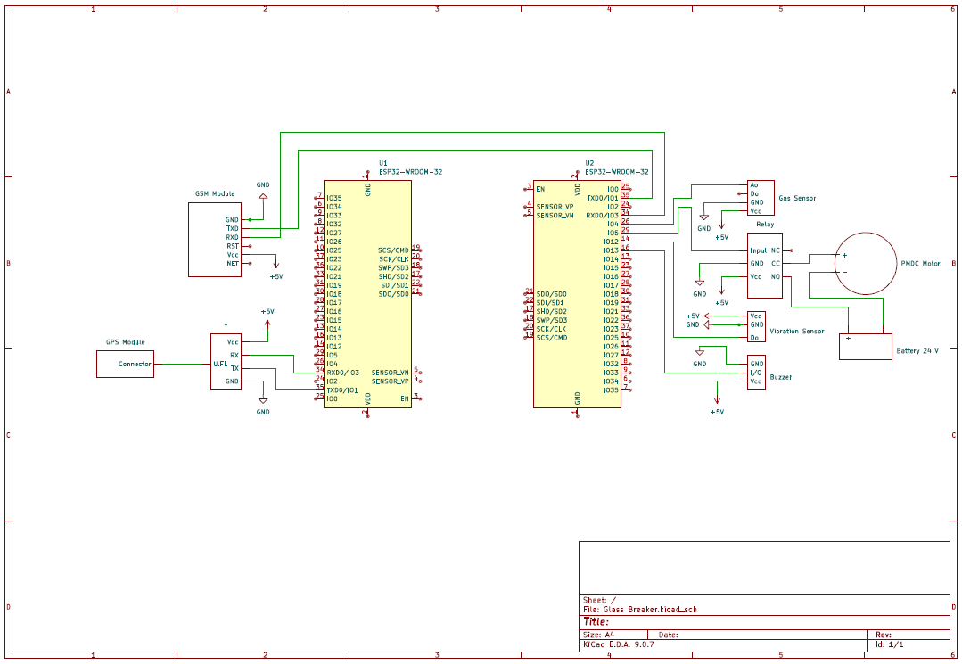
Fig. 1. Circuit Diagram

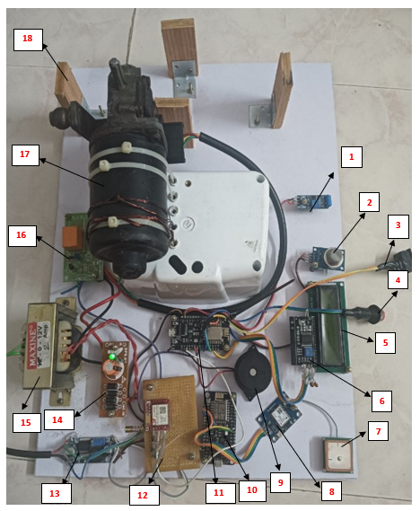
Fig. 2. Hardware Setup
1. | IR Sensor | 10. | ESP32 Microcontroller 1
2. | Gas Sensor | 11. | ESP32 Microcontroller 2
3. | Rotary Potentiometer (knob) | 12. | GSM Module
4. | Push Button / Tactile Switch | 13. | DC-DC Buck Converter
5. | 16×2 LCD Display Module | 14. | Rectifier Circuit
6. | I2C Module / LCD Backpack | 15. | Step-down Transformer (12V, 2A)
7. | GPS Receiver Module (NEO-6M) | 16. | Relay Module
8. | SIM800L GSM/GPRS Module | 17. | PMDC motor 24V
9. | Buzzer | 18. | Mechanical Frame

